# 任务单 动态加载碎片

## 演示任务：

**1、准备1个活动和2个碎片**

**（1）创建碎片AFragment,布局文件为fragment\_a，背景色为“#aabbcc”，在碎片内左上角放置文本显示框，显示“碎片A”。**

**（2) 创建碎片BFragment,布局文件为fragment\_b，背景色为“#ccbbaa”，在碎片内左上角放置文本显示框，显示“碎片B”。**

**（3）主界面顶部添加2个按钮btn\_to\_fragA、btn\_to\_fragB，剩余空间添加FrameLayout布局layout\_content。**

**2、实现动态加载所碎片**

**（1）为按钮“碎片A”、“碎片B”添加事件处理功能。**

**（2）点击按钮“碎片A”,下方切换显示碎片AFragment。**

**（3）点击按钮“碎片B”,下方切换显示碎片BFragment。**

**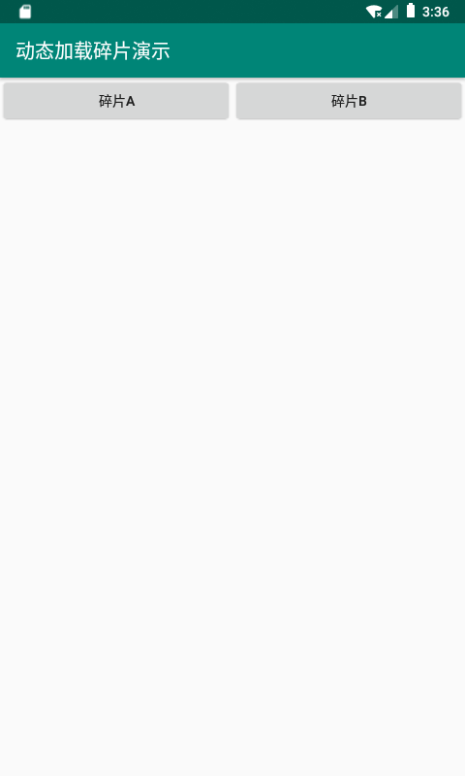**

**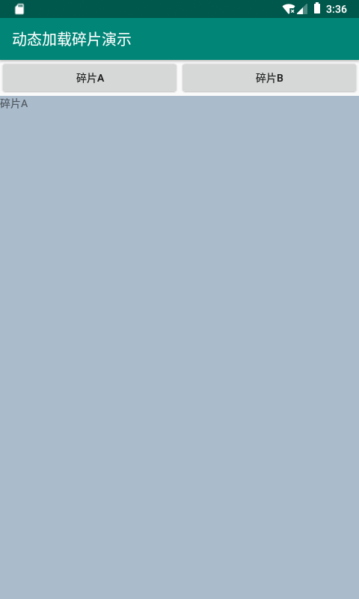 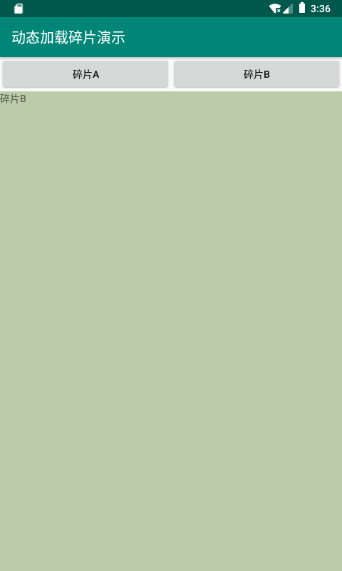**

**练习任务：**

**创建4个碎片，每个碎片包含一个图片框和一个按钮，作为一个备选任务。主界面顶部添加“下一项任务”按钮，点击按钮，在按钮下面随机加载一个碎片表示摇出一项新的任务。**

|  |  |
| --- | --- |
| **E:\安卓\安卓2_6.0\2动态加载碎片\动态加载碎片_练习项目_效果图1.png** | **E:\安卓\安卓2_6.0\2动态加载碎片\动态加载碎片_练习项目_效果图2.png** |
| **E:\安卓\安卓2_6.0\2动态加载碎片\动态加载碎片_练习项目_效果图3.png** | **E:\安卓\安卓2_6.0\2动态加载碎片\动态加载碎片_练习项目_效果图4.png** |
| **截图：**  **演示任务：** |  |

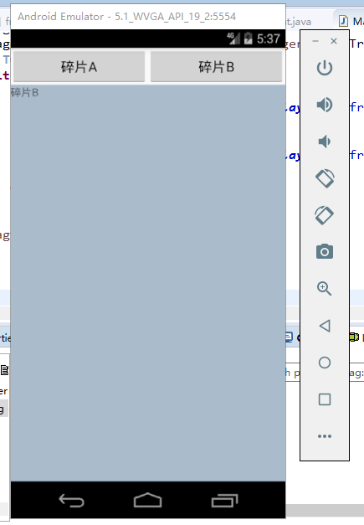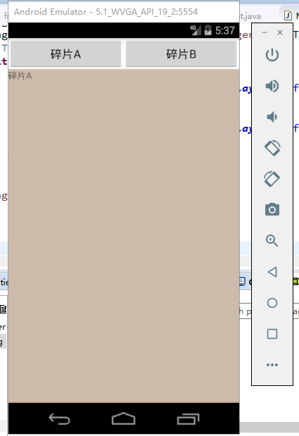

练习任务：

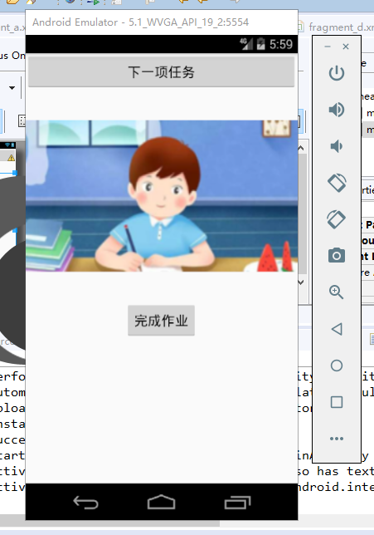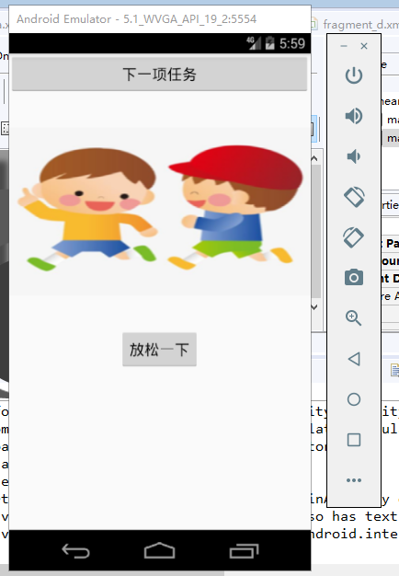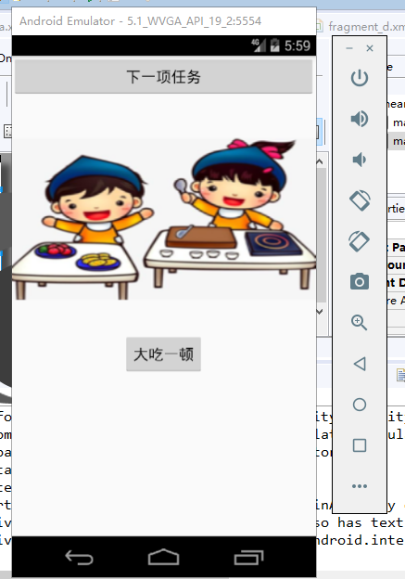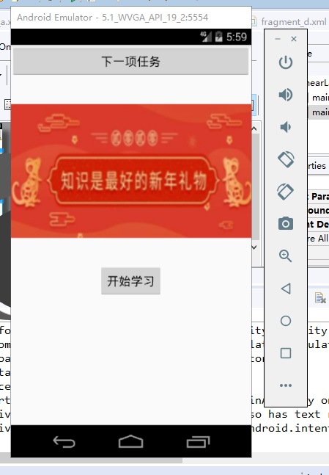

代码：

**练习任务**

布局文件：

activity\_main.xml

<?xml version=*"1.0"* encoding=*"utf-8"*?>

<LinearLayout xmlns:android=*"http://schemas.android.com/apk/res/android"*

xmlns:tools=*"http://schemas.android.com/tools"*

android:layout\_width=*"match\_parent"*

android:layout\_height=*"match\_parent"*

android:orientation=*"vertical"*

tools:context=*"${relativePackage}.${activityClass}"* >

<LinearLayout

android:id=*"@+id/main\_linear1"*

android:layout\_width=*"match\_parent"*

android:layout\_height=*"wrap\_content"*

android:orientation=*"horizontal"*>

<Button

android:id=*"@+id/main\_bt1"*

android:layout\_width=*"0dp"*

android:layout\_height=*"wrap\_content"*

android:layout\_weight=*"1"*

android:text=*"碎片A"*/>

<Button

android:id=*"@+id/main\_bt2"*

android:layout\_width=*"0dp"*

android:layout\_height=*"wrap\_content"*

android:layout\_weight=*"1"*

android:text=*"碎片B"*/>

</LinearLayout>

<FrameLayout

android:id=*"@+id/main\_fraglayout"*

android:layout\_width=*"match\_parent"*

android:layout\_height=*"match\_parent"*>

</FrameLayout>

</LinearLayout>

fragment\_a.xml

<?xml version=*"1.0"* encoding=*"utf-8"*?>

<LinearLayout xmlns:android=*"http://schemas.android.com/apk/res/android"*

android:layout\_width=*"match\_parent"*

android:layout\_height=*"match\_parent"*

android:orientation=*"vertical"*

android:background=*"#ccbbaa"*>

<TextView

android:id=*"@+id/fraga\_tv"*

android:layout\_width=*"wrap\_content"*

android:layout\_height=*"wrap\_content"*

android:text=*"碎片A"*/>

</LinearLayout>

fragment\_b.xml

<?xml version=*"1.0"* encoding=*"utf-8"*?>

<LinearLayout xmlns:android=*"http://schemas.android.com/apk/res/android"*

android:layout\_width=*"match\_parent"*

android:layout\_height=*"match\_parent"*

android:orientation=*"vertical"*

android:background=*"#aabbcc"*>

<TextView

android:id=*"@+id/fragb\_tv"*

android:layout\_width=*"wrap\_content"*

android:layout\_height=*"wrap\_content"*

android:text=*"碎片B"*/>

</LinearLayout>

JAVA代码：

AFragment.java

**package** com.example.test4frg;

**import** android.os.Bundle;

**import** android.support.v4.app.Fragment;

**import** android.view.LayoutInflater;

**import** android.view.View;

**import** android.view.ViewGroup;

**public** **class** AFragment **extends** Fragment{

@Override

**public** View onCreateView(LayoutInflater inflater, ViewGroup container, Bundle savedInstanceState) {

View vie = inflater.inflate(R.layout.***fragment\_a***, container, **false**);

**return** vie;

}

}

BFragment.java

**package** com.example.test4frg;

**import** android.os.Bundle;

**import** android.support.v4.app.Fragment;

**import** android.view.LayoutInflater;

**import** android.view.View;

**import** android.view.ViewGroup;

**public** **class** BFragment **extends** Fragment{

@Override

**public** View onCreateView(LayoutInflater inflater, ViewGroup container, Bundle savedInstanceState) {

View vie = inflater.inflate(R.layout.***fragment\_b***, container, **false**);

**return** vie;

}

}

MainActivity.java

**package** com.example.test4frg;

**import** android.os.Bundle;

**import** android.support.v4.app.FragmentActivity;

**import** android.support.v4.app.FragmentManager;

**import** android.support.v4.app.FragmentTransaction;

**import** android.view.View;

**import** android.view.View.OnClickListener;

**import** android.widget.Button;

**public** **class** MainActivity **extends** FragmentActivity **implements** OnClickListener{

AFragment afrg;

BFragment bfrg;

Button btn1, btn2;

@Override

**protected** **void** onCreate(Bundle savedInstanceState) {

**super**.onCreate(savedInstanceState);

setContentView(R.layout.***activity\_main***);

initFrag();

initView();

}

**void** initFrag(){

afrg = **new** AFragment();

bfrg = **new** BFragment();

}

**void** initView()

{

btn1 = findViewById(R.id.***main\_bt1***);

btn2 = findViewById(R.id.***main\_bt2***);

btn1.setOnClickListener(**this**);

btn2.setOnClickListener(**this**);

}

@Override

**public** **void** onClick(View arg0) {

FragmentManager fragmanager = getSupportFragmentManager();

FragmentTransaction fragtrans = fragmanager.beginTransaction();

// **TODO** Auto-generated method stub

**switch** (arg0.getId()) {

**case** R.id.***main\_bt1***:

fragtrans.replace(R.id.***main\_fraglayout***, afrg);

**break**;

**case** R.id.***main\_bt2***:

fragtrans.replace(R.id.***main\_fraglayout***, bfrg);

**break**;

**default**:

**break**;

}

fragtrans.commit();

}

}

**练习任务：**

重要的是mainactivity.java文件：

**package** com.example.test5frg;

**import** java.util.Random;

**import** android.os.Bundle;

**import** android.support.v4.app.Fragment;

**import** android.support.v4.app.FragmentActivity;

**import** android.support.v4.app.FragmentManager;

**import** android.support.v4.app.FragmentTransaction;

**import** android.view.View;

**import** android.view.View.OnClickListener;

**import** android.widget.Button;

**public** **class** MainActivity **extends** FragmentActivity **implements** OnClickListener{

AFragment afrg;

BFragment bfrg;

CFragment cfrg;

DFragment dfrg;

Button btn1, btn2;

Random ran = **new** Random();

Fragment fragarr[] = **new** Fragment[4];// 碎片数组

@Override

**protected** **void** onCreate(Bundle savedInstanceState) {

**super**.onCreate(savedInstanceState);

setContentView(R.layout.***activity\_main***);

initFrag();

initView();

}

**void** initFrag(){

afrg = **new** AFragment();

bfrg = **new** BFragment();

cfrg = **new** CFragment();

dfrg = **new** DFragment();

fragarr[0] = afrg;

fragarr[1] = bfrg;

fragarr[2] = cfrg;

fragarr[3] = dfrg;

}

**void** initView()

{

btn1 = findViewById(R.id.***main\_bt1***);

btn1.setOnClickListener(**this**);

}

@Override

**public** **void** onClick(View arg0) {

FragmentManager fragmanager = getSupportFragmentManager();

FragmentTransaction fragtrans = fragmanager.beginTransaction();

// **TODO** Auto-generated method stub

fragtrans.replace(R.id.***main\_fraglayout***,fragarr[ran.nextInt(fragarr.length)]);// 使用随机数实现随机碎片

fragtrans.commit();

}

}

AFragment.java

**package** com.example.test5frg;

**import** android.os.Bundle;

**import** android.support.v4.app.Fragment;

**import** android.view.LayoutInflater;

**import** android.view.View;

**import** android.view.ViewGroup;

**public** **class** AFragment **extends** Fragment{

@Override

**public** View onCreateView(LayoutInflater inflater, ViewGroup container, Bundle savedInstanceState) {

View vie = inflater.inflate(R.layout.***fragment\_a***, container, **false**);

**return** vie;

}

}

BFragment.java

**package** com.example.test5frg;

**import** android.os.Bundle;

**import** android.support.v4.app.Fragment;

**import** android.view.LayoutInflater;

**import** android.view.View;

**import** android.view.ViewGroup;

**public** **class** BFragment **extends** Fragment{

@Override

**public** View onCreateView(LayoutInflater inflater, ViewGroup container, Bundle savedInstanceState) {

View vie = inflater.inflate(R.layout.***fragment\_b***, container, **false**);

**return** vie;

}

}

CFragment.java

**package** com.example.test5frg;

**import** android.os.Bundle;

**import** android.support.v4.app.Fragment;

**import** android.view.LayoutInflater;

**import** android.view.View;

**import** android.view.ViewGroup;

**public** **class** CFragment **extends** Fragment{

@Override

**public** View onCreateView(LayoutInflater inflater, ViewGroup container, Bundle savedInstanceState) {

View vie = inflater.inflate(R.layout.***fragment\_c***, container, **false**);

**return** vie;

}

}

DFragment.java

**package** com.example.test5frg;

**import** android.os.Bundle;

**import** android.support.v4.app.Fragment;

**import** android.view.LayoutInflater;

**import** android.view.View;

**import** android.view.ViewGroup;

**public** **class** DFragment **extends** Fragment{

@Override

**public** View onCreateView(LayoutInflater inflater, ViewGroup container, Bundle savedInstanceState) {

View vie = inflater.inflate(R.layout.***fragment\_d***, container, **false**);

**return** vie;

}

}

布局文件：

activity\_main.xml

<LinearLayout xmlns:android=*"http://schemas.android.com/apk/res/android"*

xmlns:tools=*"http://schemas.android.com/tools"*

android:layout\_width=*"match\_parent"*

android:layout\_height=*"match\_parent"*

android:orientation=*"vertical"*

tools:context=*"${relativePackage}.${activityClass}"* >

<Button

android:id=*"@+id/main\_bt1"*

android:layout\_width=*"match\_parent"*

android:layout\_height=*"wrap\_content"*

android:gravity=*"center"*

android:text=*"下一项任务"*/>

<FrameLayout

android:layout\_marginTop=*"40dp"*

android:id=*"@+id/main\_fraglayout"*

android:layout\_width=*"match\_parent"*

android:layout\_height=*"match\_parent"*>

</FrameLayout>

</LinearLayout>

Fragment\_a.xml:

<?xml version=*"1.0"* encoding=*"utf-8"*?>

<LinearLayout xmlns:android=*"http://schemas.android.com/apk/res/android"*

android:layout\_width=*"match\_parent"*

android:layout\_height=*"match\_parent"*

android:orientation=*"vertical"*>

<ImageView

android:layout\_width=*"match\_parent"*

android:layout\_height=*"200dp"*

android:src=*"@drawable/p1"*

android:scaleType=*"centerCrop"*/>

<Button

android:layout\_width=*"wrap\_content"*

android:layout\_height=*"wrap\_content"*

android:layout\_gravity=*"center"*

android:layout\_marginTop=*"40dp"*

android:text=*"开始学习"*/>

</LinearLayout>

fragment\_b.xml

<?xml version=*"1.0"* encoding=*"utf-8"*?>

<LinearLayout xmlns:android=*"http://schemas.android.com/apk/res/android"*

android:layout\_width=*"match\_parent"*

android:layout\_height=*"match\_parent"*

android:orientation=*"vertical"*>

<ImageView

android:layout\_width=*"match\_parent"*

android:layout\_height=*"200dp"*

android:src=*"@drawable/p2"*

android:scaleType=*"fitXY"*/>

<Button

android:layout\_width=*"wrap\_content"*

android:layout\_height=*"wrap\_content"*

android:layout\_gravity=*"center"*

android:layout\_marginTop=*"40dp"*

android:text=*"放松一下"*/>

</LinearLayout>

fragment\_c.xml

<?xml version=*"1.0"* encoding=*"utf-8"*?>

<LinearLayout xmlns:android=*"http://schemas.android.com/apk/res/android"*

android:layout\_width=*"match\_parent"*

android:layout\_height=*"match\_parent"*

android:orientation=*"vertical"*>

<ImageView

android:layout\_width=*"match\_parent"*

android:layout\_height=*"200dp"*

android:src=*"@drawable/p3"*

android:scaleType=*"fitXY"*/>

<Button

android:layout\_width=*"wrap\_content"*

android:layout\_height=*"wrap\_content"*

android:layout\_gravity=*"center"*

android:layout\_marginTop=*"40dp"*

android:text=*"完成作业"*/>

</LinearLayout>

fragment\_d.xml

<?xml version=*"1.0"* encoding=*"utf-8"*?>

<LinearLayout xmlns:android=*"http://schemas.android.com/apk/res/android"*

android:layout\_width=*"match\_parent"*

android:layout\_height=*"match\_parent"*

android:orientation=*"vertical"*>

<ImageView

android:layout\_width=*"match\_parent"*

android:layout\_height=*"200dp"*

android:src=*"@drawable/p4"*

android:scaleType=*"fitXY"*/>

<Button

android:layout\_width=*"wrap\_content"*

android:layout\_height=*"wrap\_content"*

android:layout\_gravity=*"center"*

android:layout\_marginTop=*"40dp"*

android:text=*"大吃一顿"*/>

</LinearLayout>